CAPSTONE PROJECT
Problem statement 1:
Build an AI Foundry chatbot that answers FAQs using Azure OpenAI and demonstrates clear,
consistent conversations for common user questions.
Description:
Create a chatbot in AI Foundry that provides clear, consistent answers to frequently asked
questions. Use Azure OpenAI to generate responses, keep the tone professional, and handle
unknown or unclear queries politely without guessing. Demonstrate the bot using a set of
sample questions and show how it maintains reliable behavior across different user prompts.

Below is the resource I have created and utilized : faq-foundry-123
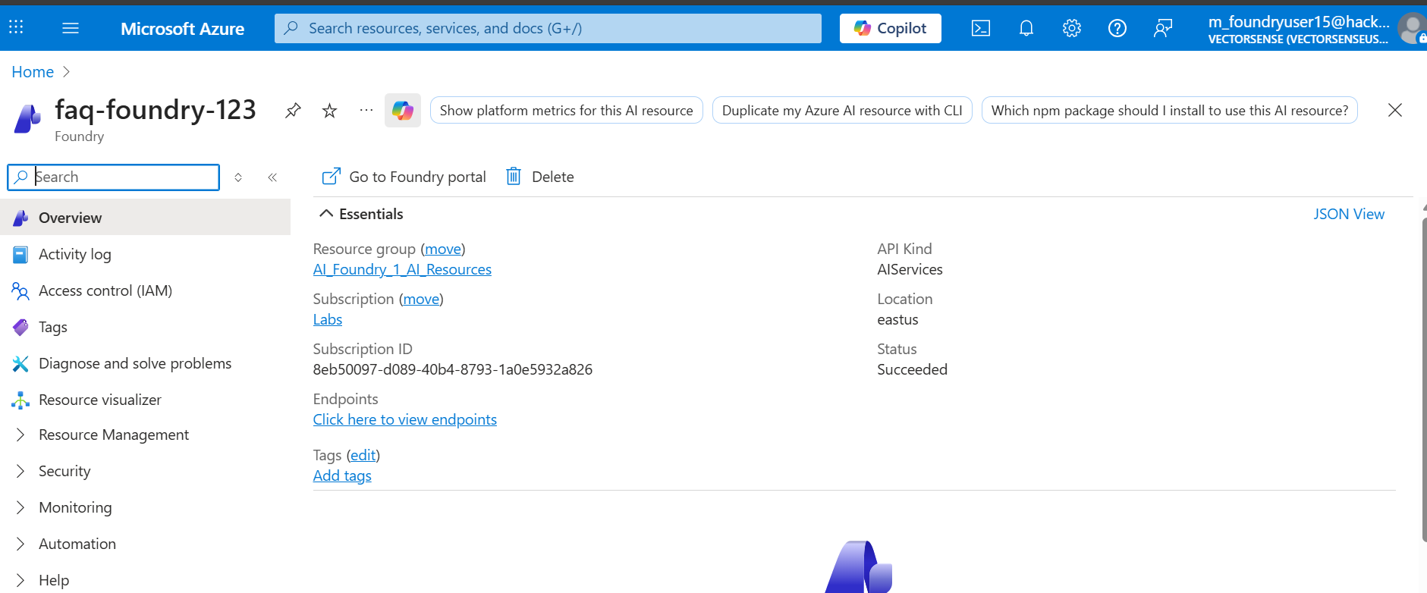

faq-agent is the agent name that I have created under the resource faq-foundry-123
And trained the agent using instructions only on a general basis
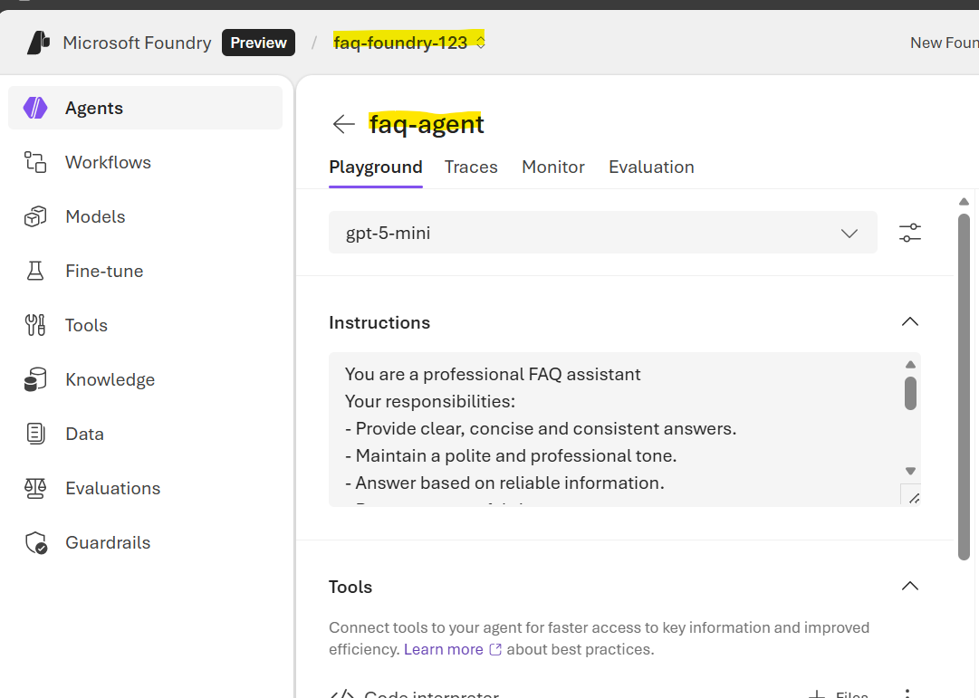
Below are the screenshots of how bot responded to different questions when instructed
It covers: all the scenarios of bot(Positive, negative and mixed scenarios)
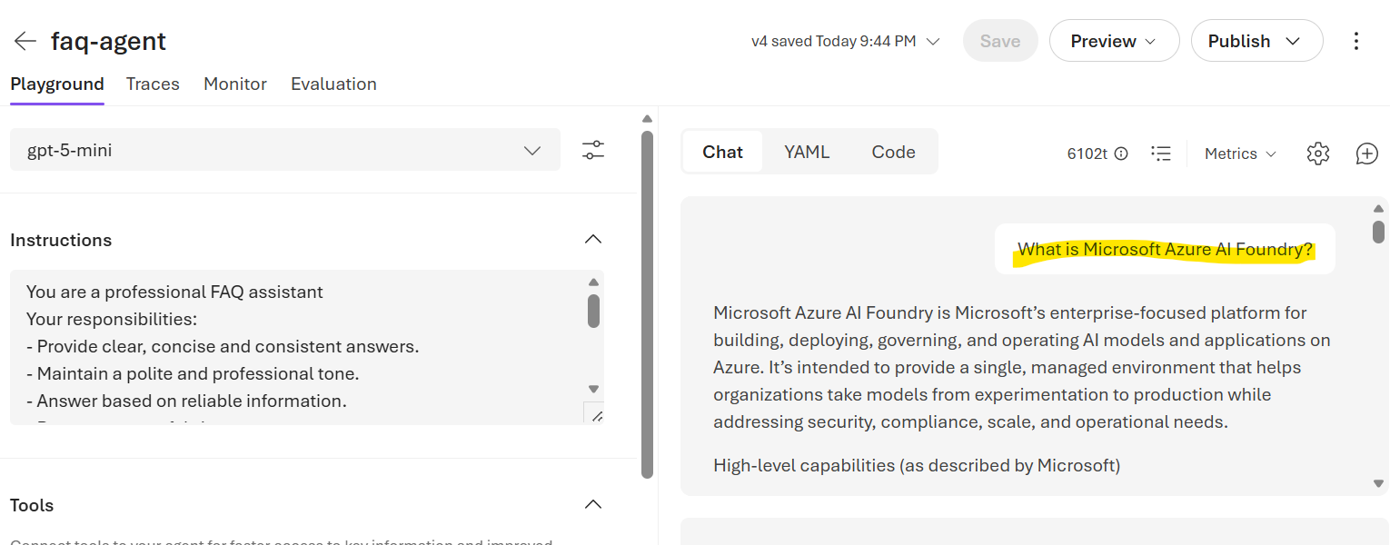

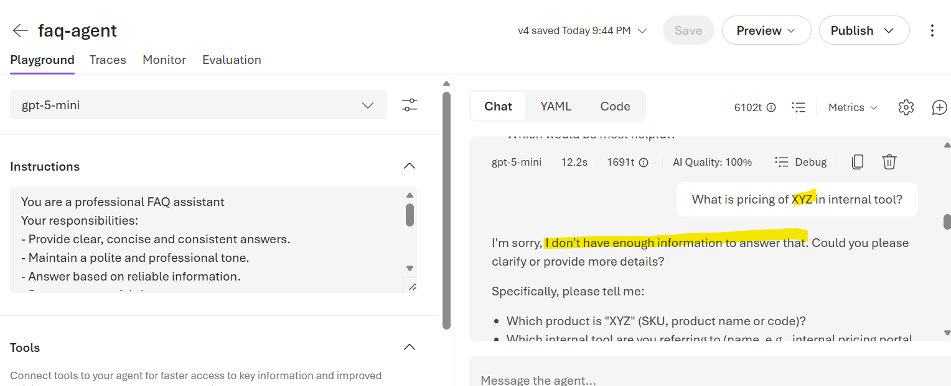

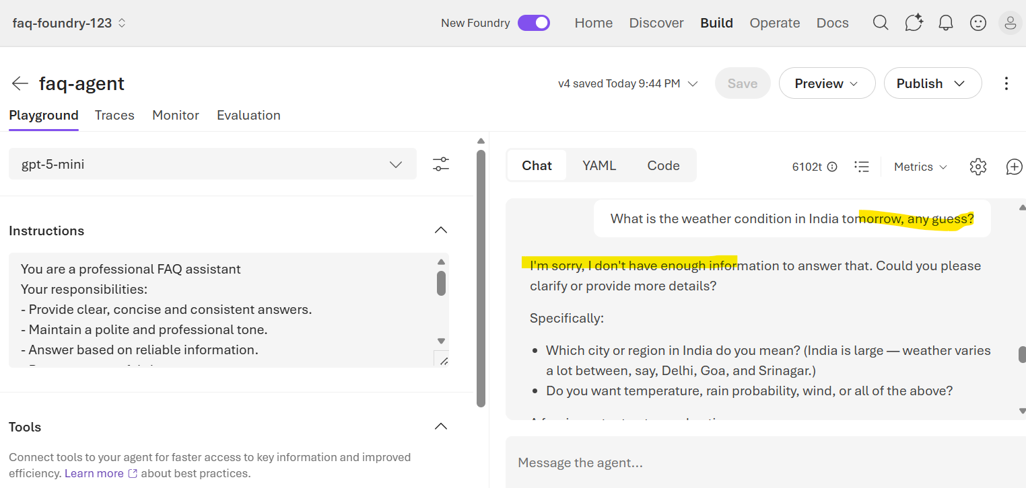

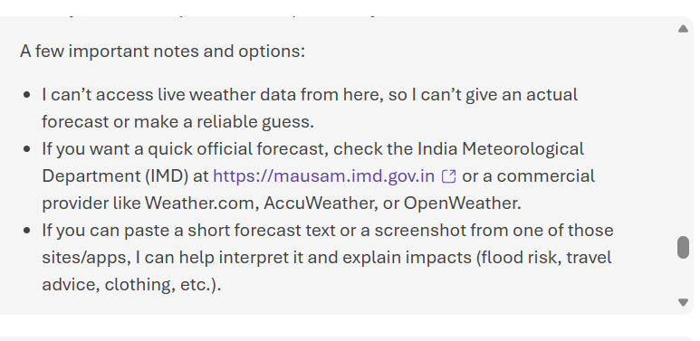

When a FAQ document is uploaded, below are the screenshots of how bot performed
